The Fish Body.
Ch 32 Holt BIO
Key Characteristics of modern fish.

WQe have discussed 3 groups of fishes and there general characteristics. Despite great variation, ALL fish share certain characteristics.

Gills
Describe the role diffusion plays in a fishes’ ability to take oxygen into the blood stream. Use labeled diagrams to enhance your explanation.

Countercurrent flow is an important concept in maximizing fishes ability to extract oxygen from water. Describe in as much detail as you can, the basic principals of countercurrent flow. Use thelabeled illustrations to enhance your answer.

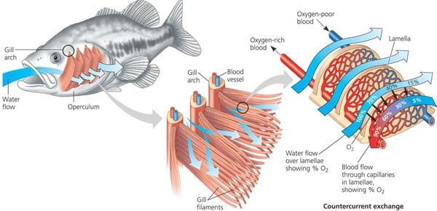

4 chambered heart with single loop circulation

Fish are the first animals we have studied that lack double loop circulation.

Imagine you are a droplet of oxygen depleted blood in the tail of a fish. Describe the journey you might make to get oxygen and deliver it to cells else where in the body of the fish. Be sure to incorporate the terms: heart, gills, lamellae, mouth, water, oxygen, capillaries, in your journey
Gill filaments ventricle atrium sinus venosus

Conus arteriosus arteries mouth veins

Water oxygen rich oxygen depleted operculum

Diffusion

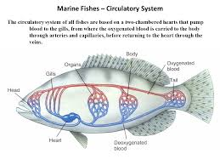

Label parts A,B,C &D.

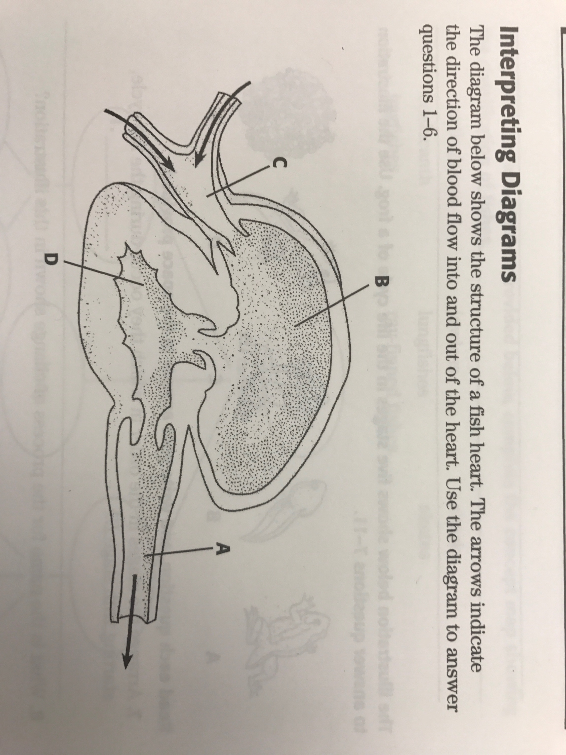

Describe how does the heart of modern fish, as pictured above is “more evolved” than the hearts of fishes ancestors. Provide a diagram of the hearts found in fish ancestors.

Why would the hearts of earlier chordates have been inadequate for modern fish?

KIDNEYS

Why is maintaining water and salt balance a different process for a freshwater fish than for a marine fish?

Explain how each type of fish controls water and salt balance. In your answer you should discuss water intake and urine production.

Freshwater fish.

marine fish.

RESEARCH and describe any relevant physiological changes that occur enabling salmon and other fish species to migrate back and forth between fresh and saltwater. Want prevents them from dying?

