Some things are more important than me

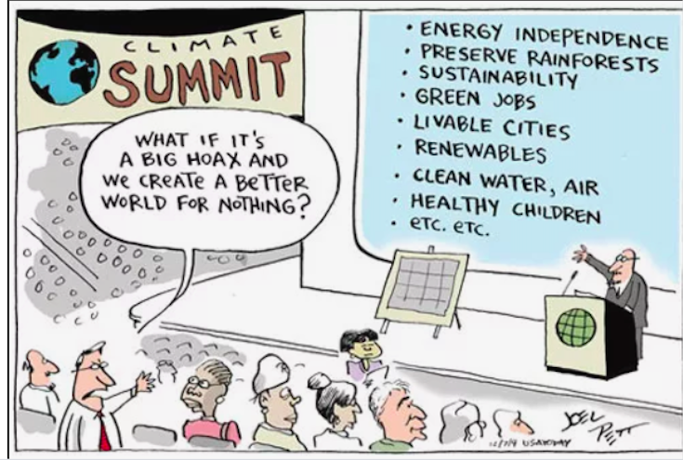

- What was my eco footprint? How does it compare to the “average”?
- What aspects of my lifestyle were most impactful?
- What environmental issue am I most concerned about?
- How am I currently contributing to the problem? How can I quantify my contribution? What units might I use?
- What am I prepared to sacrifice in order to contribute to remedying the issue?
- How does my sacrifice help remedy the issue?
- What reduction/corrective measures am i going to commit to?
- What is my goal?
- What units will I use to measure my goal?

When do I start?

- How can I persuade others that my sacrifice is valuable and important and that they should do the same.

- Make a bumper sticker that encapsulates the issue, your commitment, and the benefits of commiting.

