Penguin Species Ranges: (All penguin species live in the southern hemisphere and most spend a great deal of time swimming over a wide area of the ocean in search of food. Most species come ashore mainly to reproduce in the areas noted below.)
Species | Location
- adelie | Antarctica
- chinstrap | Antarctica
- emperor | Antarctica
- erect crested | New Zealand
- Fiordland | New Zealand
- Galapagos | Galapagos Is. (Peru)
- gentoo | Antarctica
- Humboldt | Chile & Peru
- jackass | South Africa
- king | Antarctica
- little blue | Australia
- macaroni | New Zealand
- Magellanic | Southern S. Amer.
- rockhopper | South America
- royal | New Zealand
- snares | New Zealand
- white flippered | Australia
- yellow-eyed | New Zealand

6

9
4, 5,
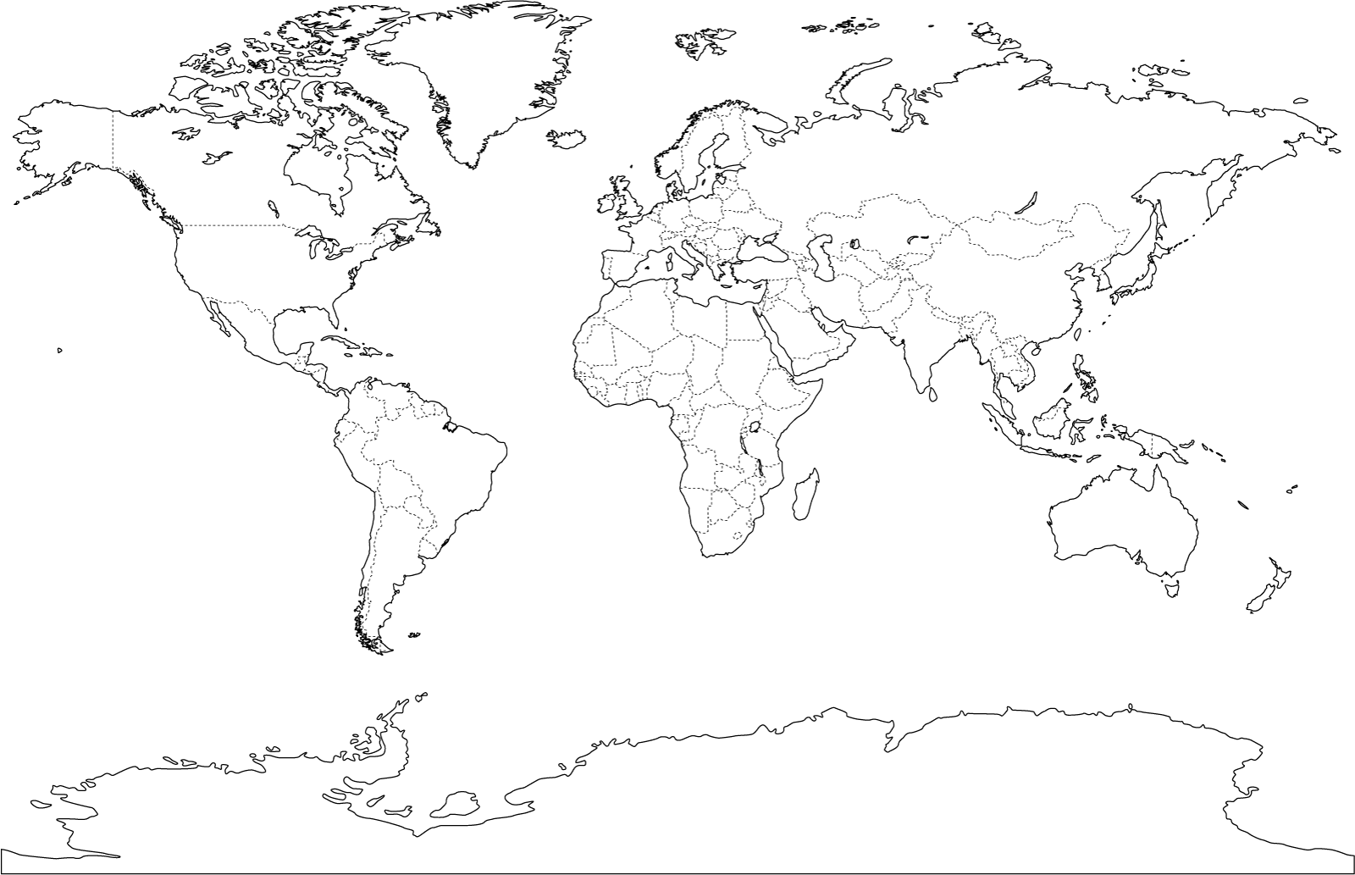
8 8 11, 17 12, 14, 12 13, 14 15, 16, 18

1, 2, 3, 7, 10

