A. Draw a floor plan for a small, 1 level house, 2 bedroom, 1 bathroom, an eat in kitchen and a living room.
Your house should incorporate the major components of a direct gain passive solar design.
On your plan show / identify the following:
- Compass rose showing the orientation of the house.
- Label all rooms
- Aperture: (highlighter)
- Absorber: illustrate or describe
- Thermal mass: Illustrate or describe
- Control: Illustrate or describe
- Distribution: Illustrate or describe

For each of the above, describe your material/ design choices, and justify why they are suitable and effective choices.

Floor plan example.

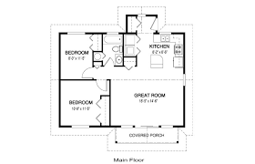

B. Draw front elevation of the south facing side of your house, illustrating the Apeture and Control features.Be creative.
Front elevation

