Locate and briefly describe any adaptations which enable the ostrich to occupy its environment so successfully. How does each adaptation differ from the “typical” bird?

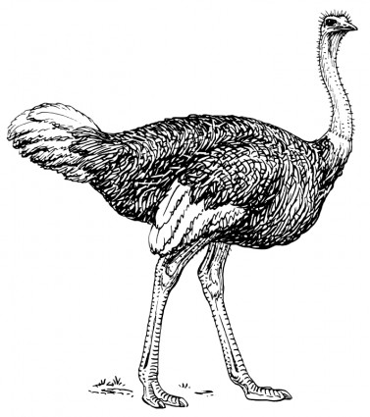

Redesign the ostrich to make it capable of flight. Consider All its adaptations and how they might need to be modified to enable flight and a lifestyle that matches its new body.
Sketch your new “Flight model ostrich”. Describe any changes you prescribed and justify them. How will your modifications help make flight possible?

