Hydrogen Power!

Learning Objectives:
In this investigation you will learn:
- Conversion of energy
- Power as the product of current and voltage
- Faraday’s first law of electrolysis
- Hydrogen is stored chemical energy

In this investigation you will explore how to gain electrical energy from combining hydrogen and oxygen.

Part 1 (Day One)
Focus Question: Can stored hydrogen be used to produce electricity?

Materials:
Safety goggles
Solar panel or hand generator
2 or 4 patch cords
Reversible fuel cell
Car with motor
Load measurement box
Distilled water
Light source (if using solar panel)
Block of wood or other support for the car
Stopwatch

Procedure:
- Place the fuel cell upside down (numbers facing down) on the lab table.
- Remove the stoppers and pour distilled water into both storage cylinders until the water reaches the tops of the small tubes in the center of the cylinders.
- Tap the fuel cell lightly to help water flow into the area surrounding the membrane and metal current-collecting plates.
- Add more distilled water until it starts to overflow into the tubes in the cylinders.
- Place the stoppers back into the cylinders. Make sure no air is trapped inside the cylinder.
- Turn the reversible fuel cell right side up.
- Plug the red banana jacks of the red patch cord into the red (positive) banana jack terminals of the solar panel (or hand generator) and the fuel cell (3).
- Repeat step 7 with the black patch cord and the negative terminals (2, 4). See diagram on back.
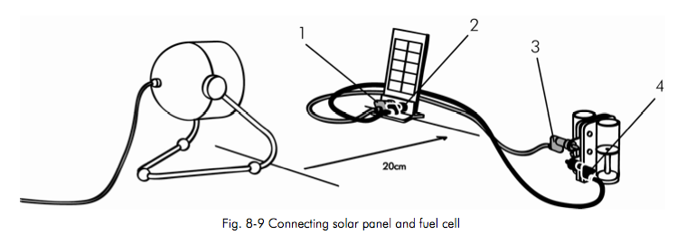

- Align the solar panel with the light source keeping a minimum distance of 20 cm. Turn on the light. (If using a hand generator, start turning the handle.)
- When the hydrogen storage cylinder is filled to a little more than 12 ml:
- Turn off the light (Stop cranking the handle).
- Unplug the patch cords from the reversible fuel cell.
- With the red and black terminals facing towards the front of the car, place the reversible fuel cell into the notches on the model car until it audibly clicks into place.

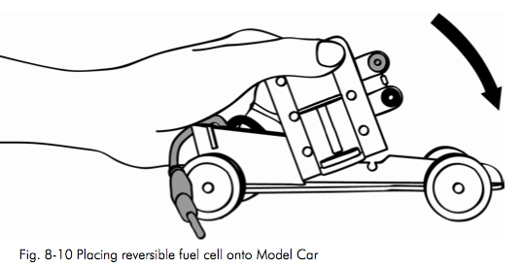

- Place the block of wood under the car base, so that the wheels on your car are free to turn.
- Connect the red (positive) banana jack with the red (positive) terminal and the black (negative) banana jack with the black (negative) terminal.
- Observe the level of gas in the hydrogen storage cylinder, and when the gas level reaches exactly 12 ml, start a stopwatch.
- Record the time after each milliliter that has been consumed, recording data in the table on the next page:
` 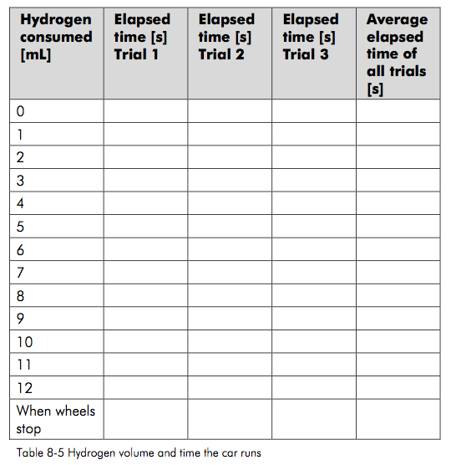

- Continue until the motor stops.
- Disconnect fuel cell and car and connect the fuel cell to the solar panel (or hand generator).

To produce hydrogen again:
18.Turn on the light (or use the hand generator) and repeat the production of hydrogen and consumption by the car as many times as you think it makes sense (at least once).

19. Create a graph of your data on the next page. Include a title.

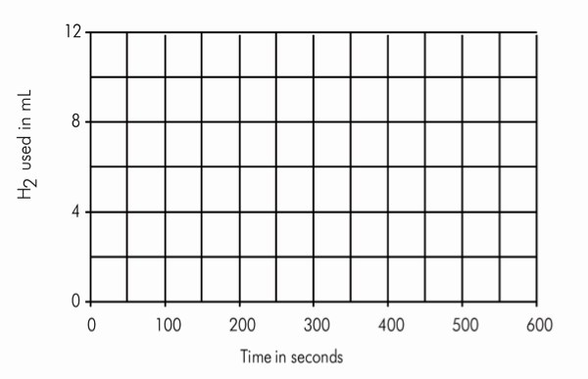

Part 2 (Day Two)
Focus Question: How much power can a fuel cell deliver?

Procedure:
- Fill the reversible fuel with distilled water (if necessary) and produce hydrogen (see steps 1-10 of last procedure).
- Set the LOAD knob (3) to OPEN.
- Connect the red (positive) terminal of the reversible fuel cell (1) to the red (positive) terminal of the ammeter at the load measurement box (2).
- Connect the black (negative) terminal of the reversible fuel cell (10) to the black (negative) terminal of the ammeter at the load measurement box (4).
- Connect the red (positive) terminal of the ammeter at the load measurement box (9) with the red (positive) terminal of the voltmeter (5) at the load measurement box.
- Connect the black (negative) terminal of the ammeter at the load measurement box (8) with the black (negative) terminal of the voltmeter (6) at the load measurement box.
- Push the ON/OFF button (7).
- Set the LOAD knob (3) to 10 Ω.

See diagram on next page.
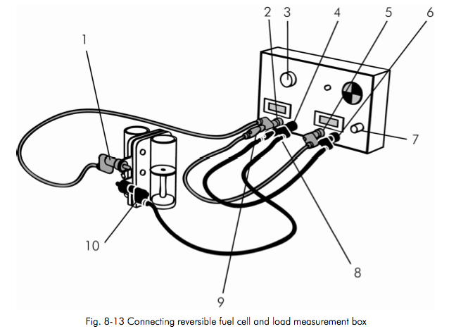
- When current and voltage appear to have settled, write them into the following table:
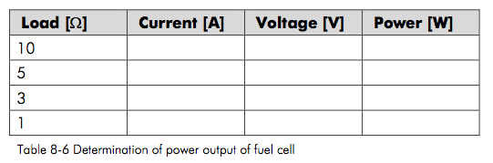
- Change the load setting to 5 Ω, 3 Ω, and then to 1 Ω and at each point record the current and voltage.
- Calculate the power output of the fuel cell.
- Disconnect the load measurement box and turn it off. Disassemble the equipment, put it away and then take off your safety goggles.

Making Meaning Questions – Answer the following questions in complete sentences.

- Why is it important to have the hydrogen gas cylinder filled with the same amount each time we start to measure the length of time the wheels turn for each mL of gas?

- What happens to the level of gas in the hydrogen storage cylinder as the wheels turn? Why does this occur?

- Could you power the electric motor with electricity produced by the solar panel? What is the advantage of powering a car with hydrogen fuel rather than a solar panel connected directly to the electric motor?

- What is the advantage of having hydrogen combine with oxygen in this way rather than having it burn and explode as it does in the hydrogen test?

- Predict how long the wheels would rotate for 20 mL of hydrogen gas. Refer to your graph and extrapolate an answer.

- Can we use stored hydrogen to produce electricity? Explain.

- When you decreased the resistance from 10 to 1 Ω, what happened to the current? What happened to the voltage? What is the maximum power output from the fuel cell you determined?

- The dependence of current and voltage you have determined is typical for batteries too. Can we say the fuel cell is a battery? Explain.

