The Black Rhino Poachers
The black rhinoceros or hook-lipped rhinoceros (Diceros bicornis), is a species of rhinoceros, native to the eastern and central areas of Africa. The black rhino grows to 14 feet (four meters) long, stands over 4.5 feet (1 meter) at the shoulder, and weighs up to 3,900 pounds (1770 kg). It is recognizable by its long, pointed, prehensile upper lip and two prominent horns, the longest of which averages 20 inches (50 cm). The horn is made up of millions of tightly compacted hairlike fibers. Poaching the rhinos for this horn has nearly wiped them out and left the species critically endangered. In the 1990s two horns from one rhino could net more than $50,000.
Wildlife biologist officials recently made a sweep of seven different suspects homes where remains of animals were found. DNA samples were obtained from each of these seven sites. Your task is to determine if any of the seven samples are in fact DNA from Dicero bicornis. A known sample of DNA will be provided.
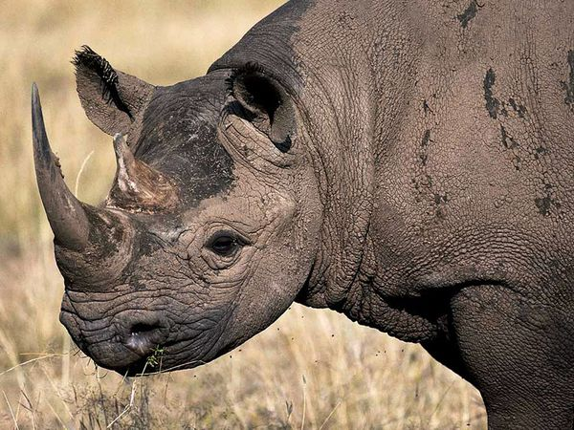
PreLab:
- Research the geographical range of the Rhino. Describe the habitat and identify the species niche.
- Provide a brief summary of the conservation status of the animal.
- How bad is their plight?
- What is your recommendation for their future?

Activity: Using Gel Electrophoresis to Solve a Crime

In this section you will take DNA samples of the seven suspects as well as the DNA found at the crime scene use gel electrophoresis to determine who committed the crime.

- Each table will have one electrophoresis chamber.
- The four students per table will break up into two groups with each group having there own gel wells.
- The first group students will run solutions A, B, C of the suspects and CS (DNA left at the crime scene).
- The second group will run D, E, F, and G of the remaining suspects.
- When the activity is completed, the two groups will compare their results to determine who left the blood sample on the glass shard.

The Crime Scene (CS) DNA sample and the DNA of the Seven Suspects

CS Crime scene DNA (known DNA from Diceros bicornis)
A
B
C
D
E
F
G
Group 1

- Label four microfuge tubes- CS, A, B, and C.

- Set the P-20 micropipette to 2 uL and dispense 2 uL dH2O to each microfuge tube.
CS, A, B, C.

- Add 8 uL CS (crime scene) DNA to the labeled CS microfuge tube.

- Eject the tip into the waste container and replace it with a fresh tip.

- Follow steps 2 and 3 for the microfuges labeled A, B, and C.

- Place all four microfuges tubes in the microcentrifuge for 10 seconds

Group 2

- Label four microfuge tubes- D, E, F, and G.

- Set the P-20 micropipette tip to 2 uL and dispense 2 uL of dH2O into each microfuge tube:
D, E, F, G.

- Add 8 uL of suspect D DNA to the microfuge tube labeled D.

- Eject the tip into the waste container and replace it with a fresh tip.

- Follow steps 2 and 3 for the microfuges labeled E, F, and G.

- Place all four microfuges in the microcentrifuge for 10 seconds.

Loading the DNA into the Gels

- Pour the melted agarose into a gel casting tray. Make sure you place two-eight teeth combs into the gel casting tray. Group 1 will use the first set of wells, and group two the second set of wells. Allow the gel to solidify before removing the two combs.

- Place the agarose gel into electrophoresis chamber. Make sure the gates are down on both sides before placing the gel into the cast tray. The wells should be located next to the negative electrode (black).

- Slowly add the 1X SB buffer into the electrophoresis chamber until the buffer covers the gel by 1-2 millimeters. Make sure the gel wells are filled with buffer. Do not connect the electrodes at this point.

Group 1

- Set the micropipette to 10uL and slowly load each sample into a separate well as indicated below. Use a fresh tip for each sample.

Well 1 add 10 uL sample CS
Well 3 add 10 uL sample A
Well 5 add 10 uL sample B
Well 7 add 10 uL sample C

- When loading each sample, center the pipette over the well and gently depress the micropipette plunger to slowly expel the sample. Use your other hand to help support your pipette hand to avoid shaking.

Group 2

- Your group will be using the second set of wells. Set the micropipette to 10uL and slowly load each sample into a separate well as indicated below. Use a fresh tip for each sample.

Well 1 add 10 uL sample D
Well 3 add 10 uL sample E
Well 5 add 10 uL sample F
Well 7 add 10 uL sample G

- When loading each sample, center the pipette over the well and gently depress the micropipette plunger to slowly expel the sample. Use your other hand to help support your pipette hand to avoid shaking.

Turning on Power Supply

- Close the cover tightly over the electrophoresis chamber. Connect the leads to the power supply, black to black and red to red.

- Turn on the power supply and set the voltage to 130 v. Press the “run” switch to begin the process. Look for tiny bubble rising in the chamber.

- Stop the process in approximately 15 minutes and unplug the electrodes from the power supply. Carefully remove the gel from the gel tray from the chamber and place it on a piece of paper toweling. Compare the pattern of both gels.

Post-Lab Questions

- Compare the dyes in the lanes of both wells to determine whose DNA matches the sample left at the crime scene. Who committed the crime?

- The crime scene suspect left behind a sample of blood at the crime scene that was used to construct a DNA profile. Are there other ways that the perpetrator could have left a DNA sample for forensic Identification?

- Besides DNA evidence, list other types of non DNA evidence that a crime suspect could leave behind that might be used as forensic evidence?

Teacher Key

The solutions contain various combinations of Bromophenol blue (purple) , Xylene cyanole (blue), and Orange G (orange).

Suspect Colors on Gel

A Porterford; the butler Orange, purple
B Colonel Hornblower; Army officer, retired Blue
C Franz; the cook Orange, purple

D Vance; the chauffeur Blue, purple
E Martini; the carpenter Orange, purple, blue
F Senorita Esmerelda; the maid Purple

G Juan; the gardener Orange

E Crime Scene Orange, purple, blue

Some Examples of DNA Uses for Forensic Identification
- Identify potential suspects whose DNA may match evidence left at crime scenes
- Exonerate persons wrongly accused of crimes
- Identify crime and catastrophe victims
- Establish paternity and other family relationships
- Identify endangered and protected species as an aid to wildlife officials (could be used for prosecuting poachers)
- Detect bacteria and other organisms that may pollute air, water, soil, and food
- Match organ donors with recipients in transplant programs
- Determine pedigree for seed or livestock breeds
- Authenticate consumables such as caviar and wine

Is DNA effective in identifying persons?
[answer provided by Daniel Drell of the U.S. DOE Human Genome Program]
- DNA identification can be quite effective if used intelligently. Portions of the DNA sequence that vary the most among humans must be used; also, portions must be large enough to overcome the fact that human mating is not absolutely random.
- Consider the scenario of a crime scene investigation . . .
- Assume that type O blood is found at the crime scene. Type O occurs in about 45% of Americans. If investigators type only for ABO, finding that the "suspect" in a crime is type O really doesn't reveal very much.
- If, in addition to being type O, the suspect is a blond, and blond hair is found at the crime scene, you now have two bits of evidence to suggest who really did it. However, there are a lot of Type O blonds out there.
- If you find that the crime scene has footprints from a pair of Nike Air Jordans (with a distinctive tread design) and the suspect, in addition to being type O and blond, is also wearing Air Jordans with the same tread design, you are much closer to linking the suspect with the crime scene.
- In this way, by accumulating bits of linking evidence in a chain, where each bit by itself isn't very strong but the set of all of them together is very strong, you can argue that your suspect really is the right person.
- With DNA, the same kind of thinking is used; you can look for matches (based on sequence or on numbers of small repeating units of DNA sequence) at many different locations on the person's genome; one or two (even three) aren't enough to be confident that the suspect is the right one, but thirteen sites are used. A match at all thirteen is rare enough that you (or a prosecutor or a jury) can be very confident ("beyond a reasonable doubt") that the right person is accused.

