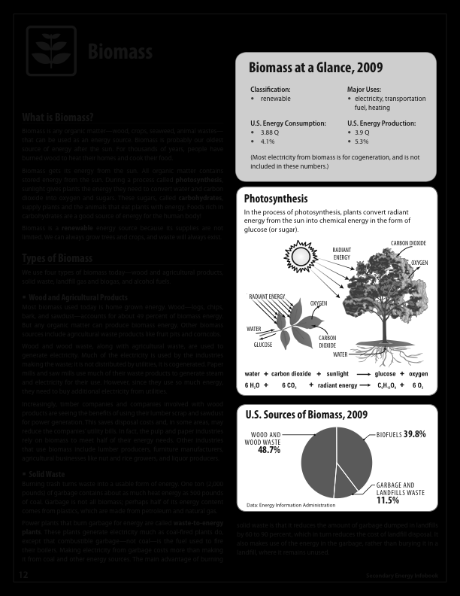

Macintosh HD:Users:christopherwren:Desktop:Secondary Energy Infobook (dragged) 2.pdf

Macintosh HD:Users:christopherwren:Desktop:Secondary Energy Infobook (dragged) 3.pdf