28-7. INTEGUMENT.
- IN THE IMAGE BELOW, USE ARROWS TO INDICATE THE FOLLOWING:
EPIDERMIS
DERMIS
HYPODERMIS

B. LABEL THE STRUCTURES IN THE IMAGE BELOW. PROVIDE A BRIEF DESCRIPTION OF THEIR FUNCTIONS.
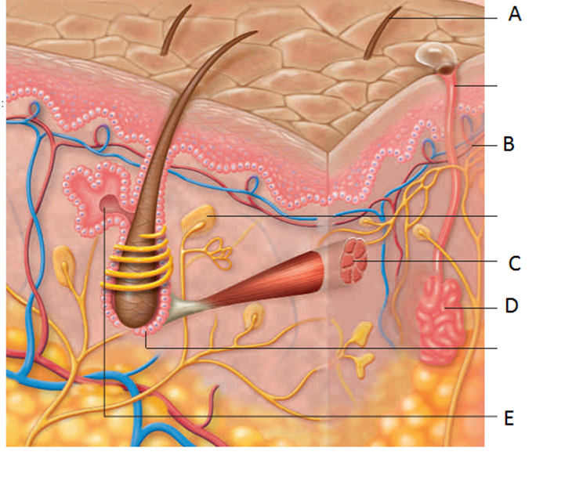
CREATE A VENN DIAGRAM, COMPARING AND CONTRASTING THE STUCTURE AND FUNCTIONS OF THE DERIS AND EPIDERMIS.

EPLAIN HOW THE PIGMENT MELANIN LEADS TO SKIN COLOUR. WHY IS MELANIN IMPORTANT?

DESCRIBE HOW LIGHT AND DARK SKIN PROVIDE CERTAIN ADVANTAGES IN THEIR RESPECTIVE LATITUDES.

HOW CAN LIFESTYLE CHOICES BE DAMAGING TO OUR EPIDERMIS.

MUMMY, WHY IS GRANDMA WRINKLY???

