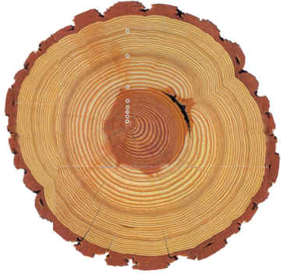

Examine the image of a cross section of a tree.

Identify 5 unusual, irregular or stiking features of the cross section. Label them with an arrow, and list them below. What is it that you notice about the feature? Offer an explanation as to what may have cause it.

1.

2.

3.

4.

5.

