Create a series of journal style entries to describe the process of seed germination.

Your entries should describe the events of the stages illustrated along the bottom of the diagram. Be descriptive.

The reader should know what each feature is, what it becomes, and what its function is.

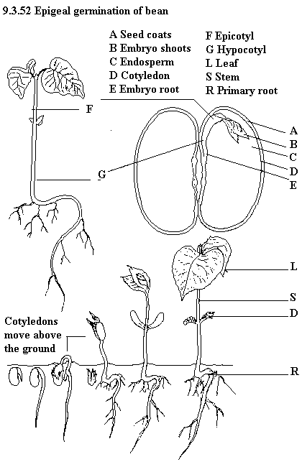
Use as much relevant vocabulary as possible.

