Macintosh HD:Users:christopherwren:Desktop:Secondary Energy Infobook (dragged) 12.pdf

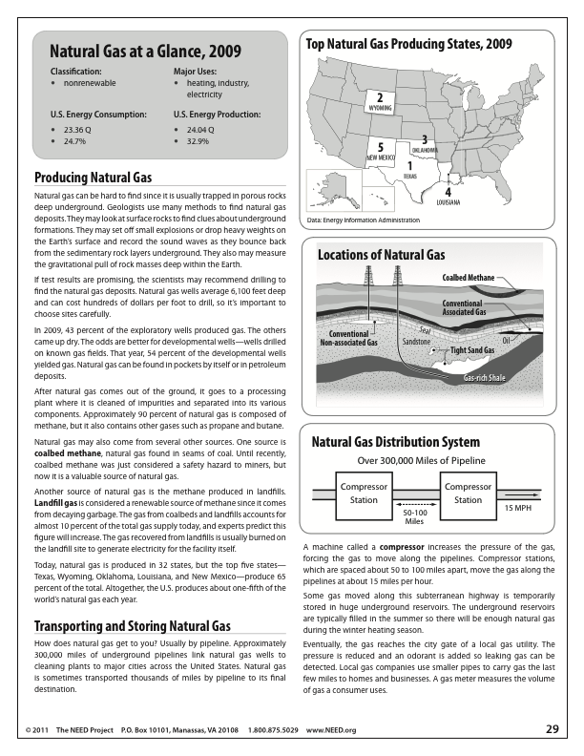

Macintosh HD:Users:christopherwren:Desktop:Secondary Energy Infobook (dragged) 14.pdf