Today’s Objectives
Define key fish-related terms used in both lab and lecture.
Acquire basic understanding of the internal and external anatomical structures of fish.
Begin exploring the relationship between structure and function.

External Anatomy
All of our fish identification will be based on external anatomy. Therefore it is essential to be able to identify key characteristics of fish external anatomy.

Before you dissect the fish, key it out to family and write down the family here: _________________
genus & species: _________________
Next, make the following measurements:

Total length (cm) _______ Standard length (cm) _______

Fork length (cm) ________

In the field, the coloration of fish can be important to their identification. What notable skin colorations do you see on your particular fish? Do you see a pattern in the fish’s coloration?

What purpose might that pattern, or lack thereof, have to the ecology of the fish?

Sketch your fish carefully and identify the fins: Caudal, Pectoral, Pelvic, Anal, Dorsal, and Adipose (only on some fish). Sketching is an important component to recognizing features because it makes you look carefully at the different characteristics of the fish. Use the diagrams at the end as a guide.

Note that fins consist of rays projecting from the body, which are typically connected by a membrane. The number of rays on the fins is often an important characteristic in fish identification. Practice counting the number of dorsal fin rays and anal fin rays. Note that spines are not rays.

How many rays does your fish have on its anal fin? What about the dorsal fin?

How many spines does your fish have on its anal fin? And the dorsal fin?

Find the following structures on your fish
Operculum Caudal Peduncle Nares
Maxilla Anus Gills
Pre-maxilla Lateral Line Scales

Using tweezers, try to pluck a scale out. Can you see rings? Count them and this will tell you the approximate age of the fish. You may need to use a magnifying glass.
# of rings: _________

Looking at the scales on your fish. What shape are they? Sketch below.

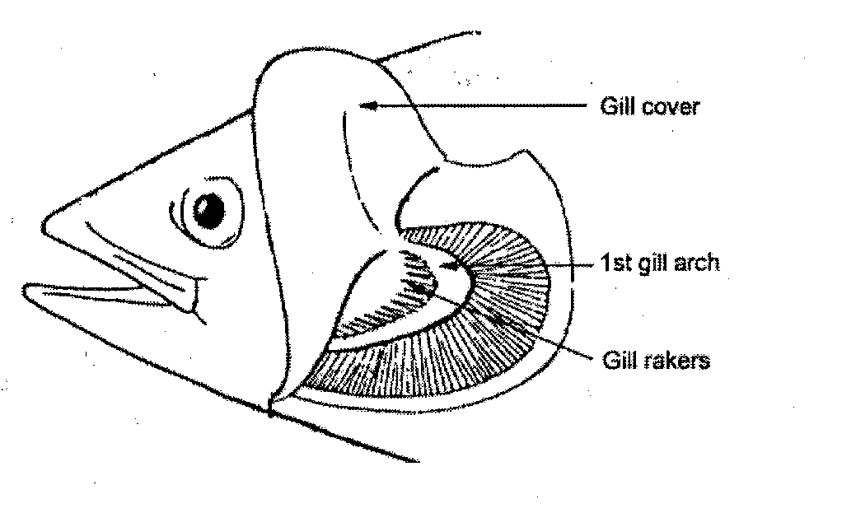
Examine the gill area of your fish. Lift and then lower the opercula; do any other structures move away from the main body of the fish? Which ones?

Distend or stretch the lower jaw of your fish. In a non-preserved fish you would notice how flexible the skin is on the posterior edges of the maxilla-premaxilla process (see bass mounts in front of class). Think about how the fish uses its mouth for both breathing and feeding; what attributes of the mouth and operculum do you think help it with these processes?

Internal Anatomy
BE CAREFUL WHEN USING SCALPELS, SCISSORS, OR PROBES

Expose the gills of the fish by lifting up the operculum with you thumb and cut towards the mouth, allowing the operculum to easily open. Be careful not to cut through the gill membranes beneath the operculum. It may be easiest to use scissors to cut through the operculum.

Identify the gill arches, gill filaments and gill rakers. Are there large gaps between gill rakers? Are gill rakers from different gill arches the same length?

Look at the gill rakers in the front of the room. How do the gill rakers on the other fish species compare to those of your fish? Ecologically, what could this tell you about the behavior of these fish?

Expose the abdominal cavity and pericardial cavity of your fish: first make a shallow longitudinal incision extending from the anus to between the gill arches. You’ll need to use scissors to get through the pelvic fin girdle. Now, make a vertical cut from the anus to the lateral line, and another vertical cut from the abdominal cavity along the posterior edge of the operculum. The abdominal cavity is lined by a thin membrane called the peritoneum.

Identify the following features:
Heart Kidney
Stomach Gonads
Liver Fat deposits
Intestine

If you currently cannot see the swim bladder make an incision parallel to and dorsal to the first cut, so that one half of the left side of the fish is now exposed. This should give you a good view of the swim bladder (may not be visible, but look for the cavity anyway).

Chop the tail of your fish off just behind the anal fin (use the third figure below as a guide).

Try to identify red muscle tissue and white muscle tissue (preserved fish lose coloring, this may be challenging).

FINAL QUESTION

1. Pick one external feature and one internal feature and describe how you think this particular structure might influence the ecology of the fish. It is OK to guess here if you don’t know, the point is to think about fish and factors that influence their abundance, distributions or interactions (ie., the white perch does not have large sharp teeth suggesting it doesn’t eat the same things as a muskie or a northern pike or a great white shark).

