Background Information
Homeostasis is the regulation and maintenance of the internal environment by an organism to
maintain a condition of balance or equilibrium. The human body, for example, maintains a
temperature of 37°C (98.6°F). However, if you were to run a mile, your temperature would rise and
your body would make adjustments to return to its steady, homeostatic state.
Homeostasis is an internal feedback mechanism sustained by a complex system of feedback loops that utilizes communication between the brain and body to respond to stimuli, such as temperature fluctuations. A feedback loop consists of three basic parts: a receptor, control center, and effector.
Receptors gather information about conditions inside and outside of an organism. The control center is typically the brain and receives signals from the receptors. It processes this information and compares it to set points or ideal conditions at which the organism functions best. When conditions move above or below a set point, the control center responds by sending a signal to an effector. Effectors are targets such as cells, muscles, or glands that change their level of activity in response to the stimuli.
An example of an internal feedback mechanism is the control center in your brain, which is
responsible for thermoregulation. It is a small structure called the hypothalamus, which contains
receptors that detect slight changes in the temperature of your blood. When you exercise, your
temperature rises and your brain sends signals to sweat glands, blood vessels in the skin, as well
as the heart and lungs. In this case, the response is to cause the sweat glands to increase their
activity, dilate blood vessels near the skin, and increase both heart and breathing rates. This allows
heat to be carried away from the center of the body to the surface, so that excess heat is released
outward. As the sweat evaporates and heat radiates away from your skin, the temperature of your
blood cools down to normal levels and the control center stops its signals to sweat glands and
blood vessels. This is similar to the way an air conditioner turns off after the room reaches a set
temperature.
Negative Feedback
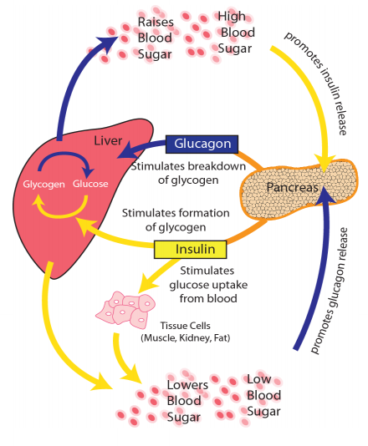
In negative feedback, a control center reverses any change in the body that moves conditions above or below a set point, thus keeping the internal environment stable. Body temperature and regulation of blood sugar levels are examples of negative feedback loops.
To maintain a constant blood glucose level, your body relies on the hormones insulin and glucagon. If blood sugar levels are low, glucagon is released by the pancreas, which stimulates the liver to increase blood sugar levels. If the amount of glucose is too high, signals are sent to the pancreas to release insulin. Insulin causes the liver to convert more glucose to glucagon resulting in lower blood sugar.

Positive Feedback
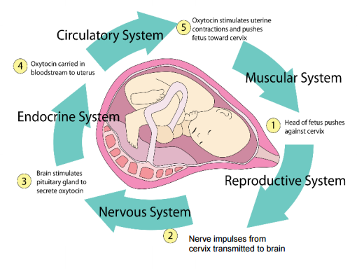
In positive feedback, a stimulus increases a rate of change away from set points. For example, during childbirth, as the baby moves toward the birth canal, it pushes on receptors in the muscular part of the cervix. Nerve signals are sent to the hypothalamus, stimulating the pituitary gland to release the hormone oxytocin. Oxytocin stimulates contractions and speeds up labor. The loop will stop when the pressure is relieved, as the baby and the placenta leave the birth canal.
1. Define homeostasis.
2. Describe two examples of the homeostasis process in humans.
3. What is the relationship between the control center and the effector in a feedback loop?
4. How does your body respond to overheating? Explain this process in terms of both internal and external signals and homeostasis.

Part I: Plan Your Investigation
You will conduct an experiment to measure the changes in your blood pressure, heart rate, and
breathing rate after a given stimulus. Many stimuli exist that can cause changes (in either direction) to these systems such as running in place, holding your breath, lying down, and doing push-ups. Select a stimulus that can be tested in your classroom, and determine how long the stimulus will last (at least one minute is recommended).
Question of Inquiry:
With your class and teacher, discuss the question of inquiry and list the materials that you will need
to conduct your investigation.
1. My question of inquiry:
2. My hypothesis:
3. My prediction:
4. What is the independent variable (also known as the manipulated variable)?
5. What is the dependent variable (also known as the responding variable)?
Procedure:
With your class and teacher, discuss a list of procedures to conduct this experiment.
9. Create and record the procedures you discussed with your teacher and peers for this
investigation. Use additional paper as necessary.

Part II: Implement Your Investigation
Collect, Record, and Organize Data
- Based on the procedure you outlined in Part I, draw a table to record the data you collect. Use one column for "Before Stimulus", one column for "During Stimulus" and one column for "After Stimulus". Include one row each for blood pressure, heart rate, and breathing rate. Include units. Remember, in order to measure any changes, you must know the initial values, so be sure to collect your baseline blood pressure, heart rate, and breathing rate before beginning this activity.
- Develop a bar graph that communicates your findings before, during, and after the stimulus. Title your graph, label your axes, include the units of measure, and provide a legend.
- Analyze Data
- Summarize what you observed regarding blood pressure before, during, and after performing your stimulus.
- Summarize what you observed regarding heart rate before, during, and after performing your stimulus.
- Summarize what you observed regarding breathing rate before, during, and after performing your stimulus.
- Explain what might happen if your body were unable to maintain a constant temperature.
- Reflections and Conclusions
- Does the data support or refute the hypothesis? Explain
- Was your prediction correct or incorrect? Explain.
- How did the results reveal a relationship between the independent and dependent variables?
- Where could errors have been made while collecting or organizing data?
- What do you conclude from this investigation?
- What type of data did you collect, qualitative or quantitative? Justify your answer.
- Using all of the following terms, develop a graphic organizer. Use additional paper, if needed.
- Terms: homeostasis, feedback loop, control center, effector, receptor, response, signal,
stimulus, hypothalamus, and pituitary gland.

