Essential Functions of Life

Activity DNA EXTRACTION
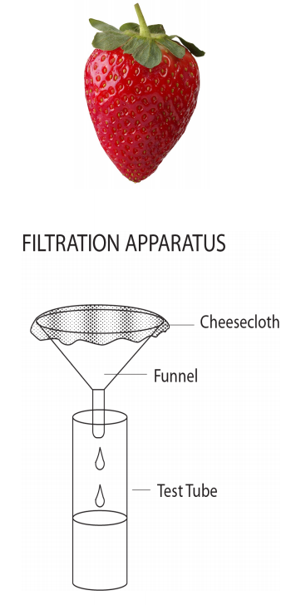
Deoxyribonucleic acid (DNA) is found in all organisms. Strawberries, because they are soft and easily pulverized, are an excellent source for extracting DNA. In addition, strawberries have very large genomes and are octoploid, which means they have eight copies of each chromosome. In contrast, humans are diploid, having only two copies of each chromosome. In this lab, you will extract DNA from the cell of an organism. An extraction buffer containing salt and dish soap will be
used to extract the DNA from the cells. The salt breaks up protein chains that hold the nucleic acids together, while the dish soap helps to dissolve the lipid layer of the cell membranes.

Procedure
- Place one strawberry in a plastic baggie.
- Smash the strawberry with your fingers for 2–3 minutes. Make sure that you do not break the bag!
- Add 10 mL of extraction buffer to the bag.
- Mix the extraction buffer and strawberry together using your fingers. Knead the mixture for one minute.
- Build the filtration apparatus as it appears in the diagram.
- Pour the strawberry solution into the filtration apparatus. The solution will take some time to drip and filter out the liquid from the solid pieces.
- Remove the filtration apparatus from the test tube. Discard the cheesecloth with remaining strawberry pulp.
- Slowly drizzle the alcohol into the test tube. Tilt the test tube so that the alcohol runs down the side of the glass.
- Hold the test tube at eye level. Can you see a white cloudy mixture where the alcohol and strawberry solution meet?
- Dip the wood skewer into the test tube where the two liquids meet.
- Gently swirl the skewer to gather the DNA.

Analysis questions
1. Draw a sketch of your observations of the strawberry DNA. If possible, use a microscope to make further observations and record the magnification.
2. Where is DNA located in the eukaryotic cell? Prokaryotic cell?
3. What is an extraction buffer? Why did you use it for this lab?
4. Recall that cell membranes are mostly composed of lipids, referred to as a phospholipid bilayer. Which part of the extraction buffer was responsible for breaking down the cell’s membranes so DNA could be released from the nucleus? Explain.
5. Would you expect a sample of human DNA to look exactly like a sample of strawberry DNA? Why or why not?

