Understanding Electrolysis Investigation

Learning Objectives:
In this investigation you will learn:
- Quantitative observations of electrolysis
- Breaking up of molecules
- Catalysts
- Electrolyzers
- Faraday’s law of electrolysis
- Identification of hydrogen and oxygen

In this investigation you will examine electrolysis in a quantitative manner. This means you will observe closely what is going on in the electrolyzer and will offer some suggestions as to what is happening.

Focus Question: What is an electrolyzer?

Materials:
Solar panel or hand generator
2 patch cords
Reversible fuel cell, used here as an electrolyzer
Load measurement box
Distilled water
Stopwatch

Procedure:
- Place the fuel cell upside down (numbers facing down) on a flat surface.
- Remove the stoppers.
- Pour distilled water into both storage cylinders until the water reaches the tops of the small tubes in the center of the cylinders.
- Tap the fuel cell lightly to help water flow into the area surrounding the membrane and metal current-collecting plates.
- Add more water until it starts to overflow into the tubes in the small cylinders in the center.
- Place the stoppers back onto the cylinders. Make sure no air is trapped inside the small cylinders.

See diagram below.
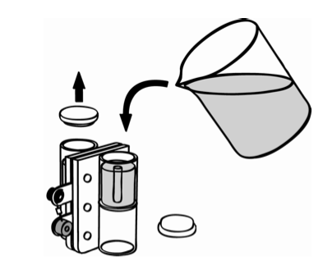

- Turn the fuel cell right side up.
- Watch the top of the small tubes for 30 seconds. Does any water come out? Write down your observation.

_________________________________________________________________________________________________

_________________________________________________________________________________________________

Read these steps carefully. Use the diagram to help you.
- Connect the red (positive) terminal of the solar panel (1) to the red (positive) terminal of the ammeter (3).
- Connect the black (negative) terminal of the solar panel (2) to the black (negative) terminal of the reversible fuel cell (10).
- Connect the red (positive) terminal of the reversible fuel cell (11) with the black (negative) terminal of the ammeter (5).
- Connect the black (negative) terminal of the reversible fuel cell (9) with the black (negative) terminal (7) of the voltmeter.
- Connect the red (positive) terminal of the reversible fuel cell (12) with the red (positive) terminal of the voltmeter (6).

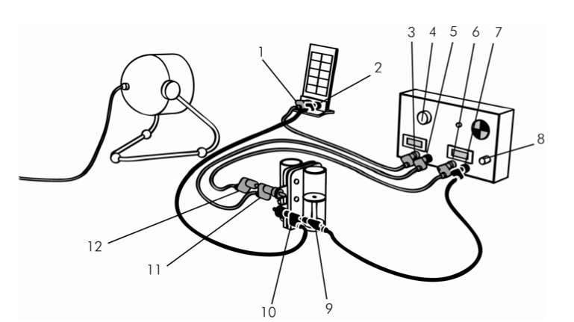
- Set the LOAD knob (4) to SHORT CIRCUIT.
- Push the ON/OFF button (8).
- Align the solar panel with the light source.
- Turn on the light.
- Position the solar panel and light so that the current is 150 mA or more.
- Watch the top of the small tubes for 30 seconds. Does any water come out? What do you think pushes the water out? Write down your observations and ideas below.

_________________________________________________________________________________________________

_________________________________________________________________________________________________

_________________________________________________________________________________________________

Continue observing and every 2 minutes record the amount of gas collected in each storage cylinder. Or you may REPLACE the solar cell with the hand generator and turn it to create a continuous source of electricity for the next 10 minutes. (Keep your test fair by turning the generator evenly for 10 minutes.)
Time from start (minutes) | Cathode (black) gas volume (mL) | Anode (red) gas volume (mL)
0
2
4
6
8
10

- When 10 mL of gas is collected in one cylinder, have the time recorded and the amount of gas in the other cylinder. This completes the table.
- Let the electrolyzer continue working until all the water has moved into the upper portion of one of the cylinders. (With optimum lighting, it should take 10-15 minutes to displace all the water into the upper hydrogen cylinder.)

Disassemble and clean up all equipment and materials.

Making Meaning Questions – Answer the following questions in complete sentences.

- Why is it important to ensure there are no large bubbles of air remaining when we fill the gas storage cylinders with water?

- Using the information provided by the labels on the gas storage cylinders, which electrode is attached to which cylinder?

- Is gas produced at similar rates at each electrode? What evidence do you have of this?

- What simple ratio can you use for gas production?

- Do you have any evidence that the labels on the cylinders are placed on the correct cylinders?

- Looking at the scientific formula for water, H₂0, what do you think happened in this investigation?

- Use the data from your table to create a graph. Include a title.

________________________________
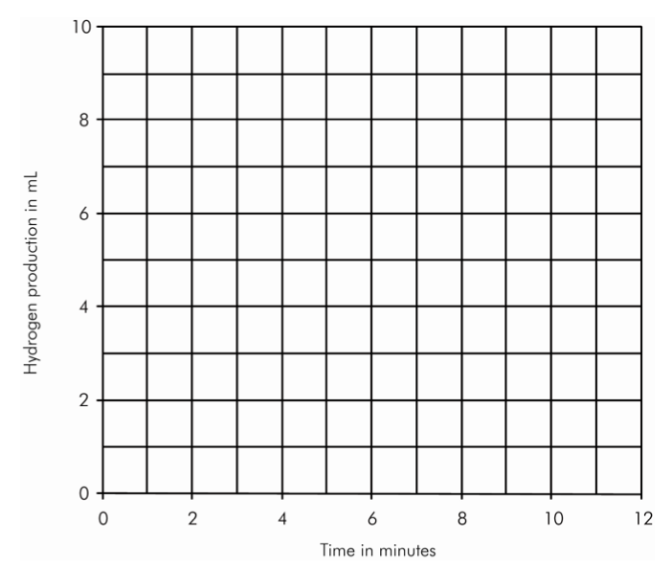
- How much gas would be produced if you ran your electrolyzer for one hour? (Hint: Extrapolate your data).

- How long would it take for you to collect one liter of cathode gas? Of anode gas?

- Using the results you obtained from this investigation, what is an electrolyzer and what does it do?

