Electrolysis Investigation

Learning Objectives:
In this investigation, you will learn:
- Breaking up of molecules
- Chemical reactions
- Structure and properties of matter
- Behavior of ions
- Electrical charge, anode, cathode
- Electrolytes
- Oxidation, Reduction

Focus Question: Can electricity take apart water?

In this investigation you will apply electrical power to water/salt solution and observe the findings.

Materials:
Solar panel with lamp or hand generator
2 patch cords (alligator clips)
Pencil
2 10cm x 5cm pieces of aluminum foil
150 mL distilled water
1 T of table salt
Tape
Ruler

Part 1 Procedure:
- Roll one piece of aluminum foil around a pencil.
- Use a small piece of tape to hold the foil in a cylinder around the pencil and slide it carefully off the pencil creating a cylinder.
- Place one end of the cylinder over the metal tip of a patch cord, squeeze the foil and wrap that end tightly with tape so it is secure.
- Flatten the other end of the foil cylinder, forming an electrode.
- Repeat these steps with the other piece of aluminum foil and patch cord.
- Obtain 150 mL of distilled water in a 250 mL beaker.
- Bend the aluminum electrodes and hang them on the edge of the beaker with the electrode immersed in the water. The metal ends of the patch cords should not touch the water directly.
- If you are using the solar panel, place it directly facing the light source, but not closer than 20 cm.
- Turn on the light, but do not connect the patch cords yet. (See diagram, page 2.)
- If you are using the hand generator, attach the patch cords, but do not start turning the handle.

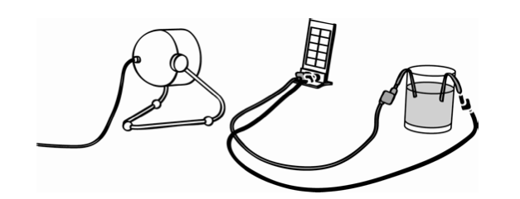
What do you think is going to happen when you connect the patch cords to the solar panel? Why? Answer before you continue.

______________________________________________________________________

______________________________________________________________________

Connect the patch cords to the solar panel or start turning the hand generator and observe what is happening under the water on the surface of each electrode.

Part 2 Procedure:
- Lift the electrodes out of the water and set them aside. Add 1 T of salt to the water and stir until the salt is completely dissolved.
- Replace the electrodes in the water/salt solution.
- Observe and write down what is happening under the salt solution on the surface of each electrode in the space below as you turn the generator or when you place the solar panel under the light.

Clean-Up:
Remove the electrodes from the salt solution and pull them off the patch cords. Dispose of the aluminum foil properly. Empty the salt-water solution and wash the beaker. Turn off the light source and let the solar panel cool down. Disconnect the patch cords and return all equipment as directed.

Making Meaning Questions – Answer the following questions in complete sentences.

- Why is salt added to the water and how does it change what happens when the electrodes are under the water and connected to the solar panel or hand generator?

- During electrolysis, the electrode attached to the black patch cord is called the CATHODE. Is the cathode positive or negative with respect to the other electrode?

- During electrolysis, the electrode attached to the red patch cord is called the ANODE. Is the anode positive or negative with respect to the other electrode?

- When the patch cords were connected to the solar panel or the hand generator, what did you notice happening at the cathode when you observed carefully?

- Was the same thing happening at the anode? What do you think is the reason for any differences in your observations?

- What evidence do you have that water can be separated using electricity?

- Looking at the scientific formula for water, H₂0, what do you think happened in the investigation?

- What is the scientific name for this process?

