DO Activity#2 DNA puzzle.
The unique structure and bonding abilities of the DNA molecule lend to its functionality. The true
nature of DNA was finally unlocked after years of work by many notable scientists. The current
model of DNA was proposed in 1953. Today, you will discover the model for yourself.
Procedure:
1. Cut out the puzzle pieces provided by your teacher.
2. Fit the individual pieces together, lengthwise, like a puzzle.
3. Sketch or glue an image of the puzzle in your lab journal.
4. How would you describe the structure of the puzzle you put together?

5. What did you notice about the individual puzzle pieces? Could they have fit together in any other way?
- 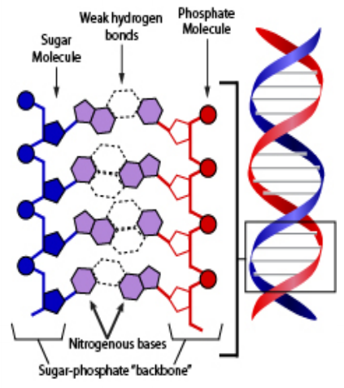Read the following passage about DNA. Think about the puzzle you just put together while reading it.
- After reading the passage, return to the puzzle you sketched and label it using the following four bulleted points:
- Deoxyribose (sugar molecule)
- Phosphate
- Nitrogen bases
- Hydrogen bond
All known forms of life contain ribonucleic acid (RNA) and deoxyribonucleic acid (DNA), which are found in abundance in all living cells, from single-celled prokaryotes to complex eukaryotes, such as human beings. DNA needs to be coded, transmitted, and expressed. To understand how DNA carries information about the physical traits of an organism, it is necessary to first understand the structure of the DNA molecule.
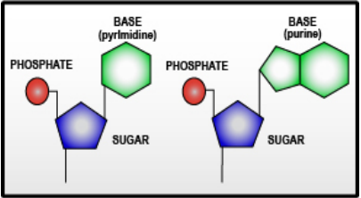
DNA consists of repeating monomers called nucleotides. Each nucleotide consists of three parts as illustrated on the right:
- Phosphate group
- Five-carbon (pentose) sugar
- Nitrogenous base
The phosphate group is attached to one end of the five-carbon sugar. The phosphate of one
nucleotide binds to the sugar of the next to form what is called the sugar–phosphate backbone.
The sugar, deoxyribose, gives DNA part of its name.
There are four nitrogenous bases within DNA: adenine (A), thymine (T), cytosine (C), and guanine
(G). These four bases can be further divided into two groups based on their atomic structure: (A)
and (G) are called purines, while T and C are called pyrimidines. Each of the nitrogenous bases
has a specific partner with which it shares a hydrogen bond. Adenine always binds to thymine by
forming two hydrogen bonds , and cytosine always binds only to guanine by forming three
hydrogen bonds. Look back at the image from your puzzle to see if you can identify which pieces
are adenine, thymine, cytosine, and guanine.
The entire structure of DNA looks like a ladder twisted into a spiral. This shape is known as a
double helix.
1. Label the nitrogenous base pairs on your DNA puzzle model Be sure to correctly follow the base pairing rule.
2. What are the three parts of a nucleotide in a DNA molecule?
3. Describe what is found in the “backbone” of a strand of DNA. What is it composed of?
4. Describe what “base-pairing” means. What did you have to pay attention to when you were building your DNA model?
5. What is an advantage to building a model of DNA? What are two limitations of the DNA model you created? What properties of DNA cannot be demonstrated using this model?

