Macintosh HD:Users:christopherwren:Desktop:Secondary Energy Infobook (dragged) 4.pdf

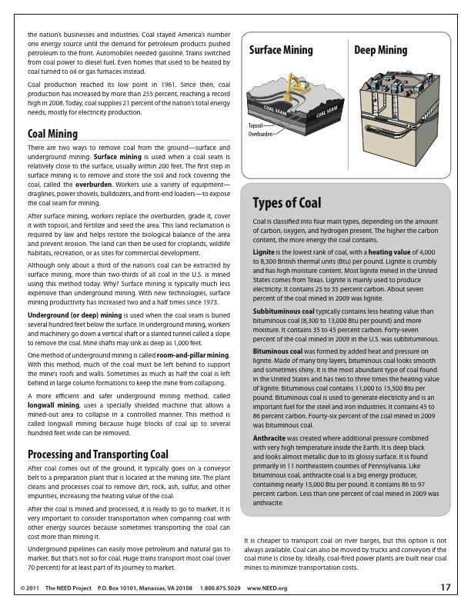

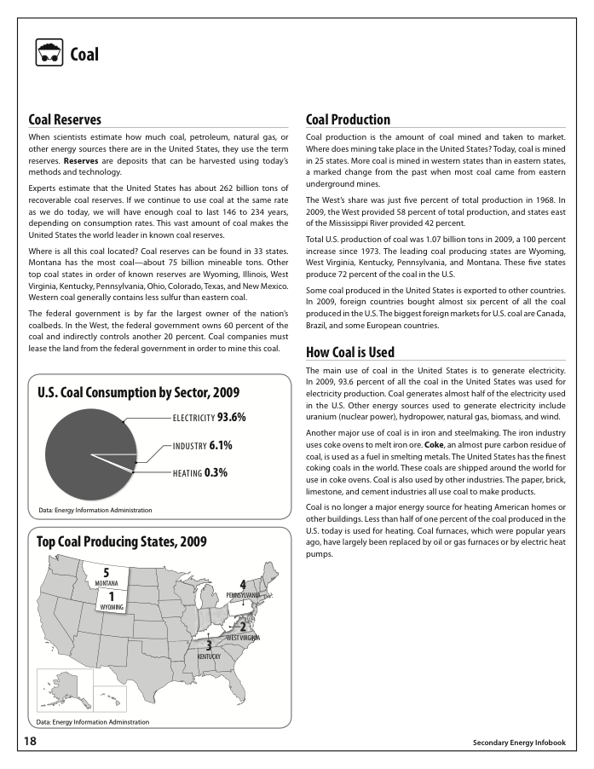

Macintosh HD:Users:christopherwren:Desktop:Secondary Energy Infobook (dragged) 7.pdf