Using Blood Tests to Identify Babies and Criminals
Copyright, 2010, by Drs. Jennifer Doherty and Ingrid Waldron, Department of Biology, University of Pennsylvania

I. Were the babies switched?
Two couples had babies in the same hospital at the same time. Michael and Danielle had twins, a boy, Michael, Jr., and a girl, Michelle. Denise and Earnest had a girl, Tonja. Danielle was convinced that there had been a mix-up and she had the wrong girl, since Michael Jr. and Tonja were both light-skinned, while Michelle had darker skin. Danielle insisted on blood type tests for both families to check whether there had been a mix-up. In order to interpret the results of the blood type tests, you will need to understand the basic biology of blood types.

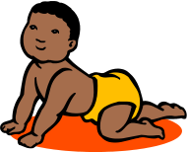

Blood Types
There are many different ways to classify blood types, but the most common blood type classification system is the ABO (said "A-B-O") system. There are four blood types in the ABO system: Type A, Type B, Type AB, and Type O. These blood types refer to different versions of carbohydrate molecules (complex sugars) which are present on the surface of red blood cells.
People with: | Have:
Type A blood | Type A carbohydrate molecules  on their red blood cells | 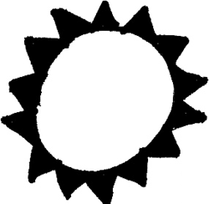
Type B blood | Type B carbohydrate molecules  on their red blood cells | 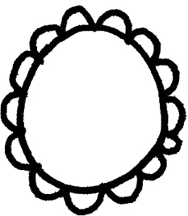
Type AB blood | Type A and B carbohydrate molecules  on their red blood cells | 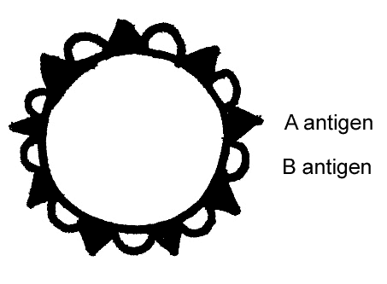
Type O blood | Neither A nor B carbohydrate molecules  on their red blood cells | 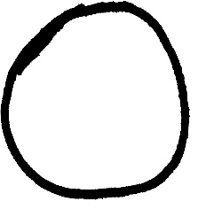

The Type A and Type B carbohydrate molecules are called antigens because they can stimulate the body to produce an immune response, including antibodies. Antibodies are special proteins that travel in the blood and help our bodies to destroy viruses or bacteria that may have infected our bodies (see figure on next page).

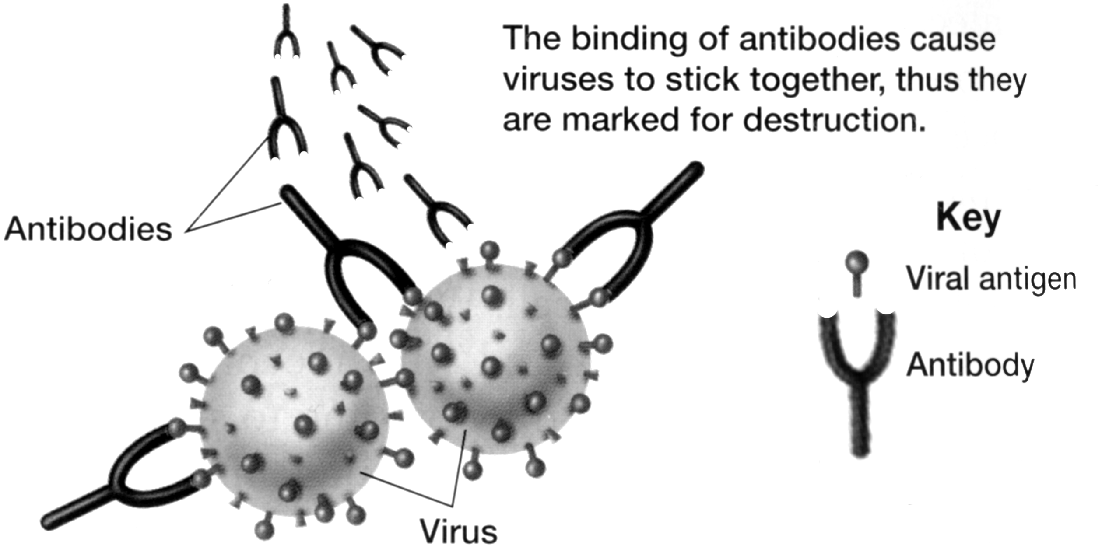
Adapted from Figure 40.5 in Holt Biology by Johnson and Raven

Normally, our bodies do not make antibodies against any molecules that are part of our own bodies. Thus, antibodies help to defend against invading viruses and bacteria, but normally antibodies do not attack our own body cells.

For example, people with Type A blood do not make antibodies against the Type A antigen which is present on their red blood cells, but they do make antibodies against the Type B antigen. Test your understanding of blood groups by filling in the blanks in the chart below.
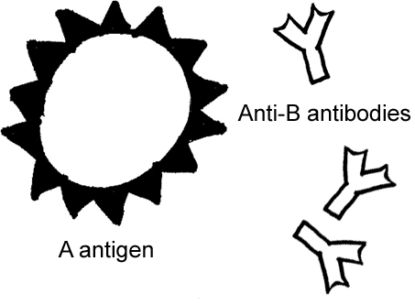 | Blood group A  If you belong to the blood group A, you have A antigens on the surface of your red blood cells and _______ antibodies in your blood.
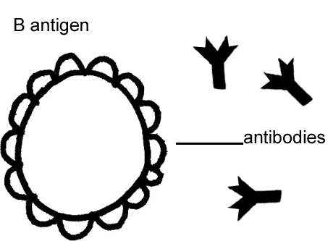 | Blood group B  If you belong to the blood group B, you have B antigens on the surface of your red blood cells and _______ antibodies in your blood.
Blood group AB
If you belong to the blood group AB, you have both A and B antigens on the surface of your red blood cells and no anti-A or
anti-B antibodies in your blood.
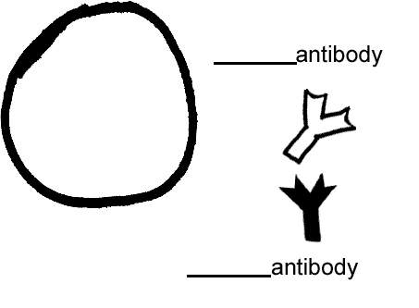 | Blood group O  If you belong to the blood group O, you have neither A nor B antigens on the surface of your red blood cells, but you have both  ______ and _____ antibodies in your blood.
Blood transfusions — who can receive blood from whom?
If you are given a blood transfusion that does not match your blood type, antibodies present in your blood can react with the antigens present on the donated red blood cells. For example, if a person who has Type A blood is given a Type B blood transfusion, then this person's anti-B antibodies will react with the Type B antigens on the donated red blood cells and cause a harmful reaction. This reaction can cause the donated red blood cells to burst and/or clump together and block blood vessels. This type of transfusion reaction is illustrated in the following drawing.
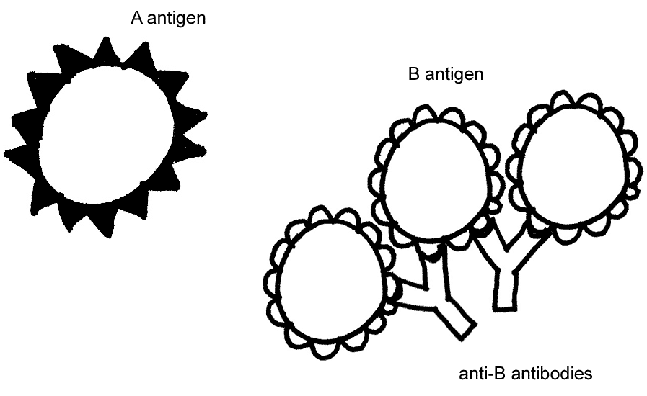
Transfusion reactions can be fatal. To prevent this from happening, doctors test whether a person's blood is compatible with the donated blood before they give a transfusion. A person can only be given donated blood with red blood cells that do not have any antigen that can react with the antibodies in the person's blood.

Test your understanding of blood groups by completing the table below.

Blood Group | Antigens on red blood cells | Antibodies in plasma | Can receive  blood from | Can give  blood to
A | A | Anti-B | A and O | A and AB
B | B
AB | A and B
O | None

Which blood type would be considered a universal donor (someone who can give blood to anyone)?

Genetics of Blood Types
Your blood type is established before you are born, by specific genes inherited from your parents. You receive one blood type gene from your mother and one from your father. These two genes determine your blood type by causing the presence or absence of the Type A and Type B antigen molecules on the red blood cells.

The blood type gene has three different versions or alleles:
I^{A} results in A antigen on the red blood cells,
I^{B} results in B antigen on the red blood cells, and
i does not result in either antigen.

Everyone has two copies of these genes, so there are six possible combinations of alleles (called genotypes) which result in the four possible blood types (phenotypes):
I^{A} I^{A} and I^{A} i - both resulting in Type A blood,
I^{B} I^{B} and I^{B} i - both resulting in Type B blood,
I^{A} I^{B} - resulting in Type AB blood,
i i - resulting in Type O blood.

In a heterozygous I^{A} i person, which allele is dominant, I^{A} or i? Explain your reasoning.

Codominance refers to inheritance in which two alleles of a gene each have a different observable effect on the phenotype of a heterozygous individual. Thus, in codominance, neither allele is recessive—both alleles are dominant.

Which one of the genotypes shown above results in a phenotype that provides clear evidence of codominance? Give the genotype and draw a picture of a red blood cell for this genotype to illustrate how both alleles influence blood type in this case.

Each biological parent gives one of their two ABO alleles to their child. For example, a father who has blood type AB has the genotype_____, so he will produce sperm with either an I^{A} or an I^{B} allele and he can give either an I^{A} or an I^{B} allele to a child of his. If the mother has blood type O, her genotype must be _____, and she can only give an ______ allele to a child of hers.

The Punnett Square below shows the possible genotypes for the children of these parents. Write in the blood type for each genotype to show the possible blood types for the children of these parents.
Father (Type AB)  Sperm | Mother  (Type O)  Eggs
Father (Type AB)  Sperm |  | i | i
Father (Type AB)  Sperm | I^{A} | I^{A} i | I^{A} i
Father (Type AB)  Sperm | I^{B} | I^{B} i | I^{B} i

Next, suppose that a mother has blood Type A and genotype I^{A} i and the father has blood Type B and genotype I^{B} i. Draw a Punnett square to show the possible genotypes for their children. Write in the blood type for each genotype.

Were the babies switched?

Now you are ready to evaluate whether Earnest and Denise's baby girl was switched with Michael and Danielle's baby girl. The following family tree shows the blood types for both families.

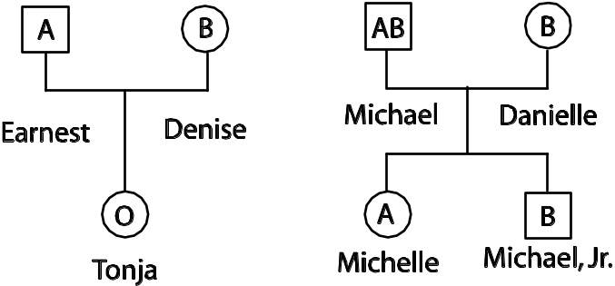

- Is it possible for Michael and Danielle to have a child who has type O blood?

How do you know this?

Was a switch made at the hospital?

- How could fraternal twins be as different in appearance as Michelle and Michael, Jr., including one having light skin and the other having dark skin?

II. Who Killed Shamari Davis?

Background
Shamari Davis was a 20-year-old college freshman who was majoring in Physical Therapy. She paid for school by working as a personal trainer at a local gym. Shamari had been promoted to head personal trainer at the gym just before she was killed.

Crime Scene
The body was found in the women’s locker room of the gym at 1 am by the night janitor, Harvey Willis. The victim had been strangled and was wearing a robe. There were signs of a struggle in the room and the glass door of the shower was broken and had traces of blood on it. The victim was pronounced dead at the scene and the coroner suggested that the time of death was at least 3 hours before the body was found.

Criminal Investigation
Shamari’s co-worker Daleesha Jones told police that Shamari was a newer employee who did not deserve her recent promotion and only got it because she spent a lot of time with their boss, Steve O’Hare. When asked if he knew if Shamari had problems at work, Steve told Police that Shamari had complained to him that one of her fitness clients, Mike Reed, kept asking her out and wouldn’t take no for an answer.

Blood Analysis
Obviously a real crime investigation would use many clues, but your investigation will be based on the simplest type of blood testing, namely testing for blood types A, B, O, and AB, for the blood sample found at the scene and for each of the possible suspects.

No individual can change blood types, and blood type does not change with age. Explain why.

In order to test blood type, you mix a sample of the blood with two different types of antiserum—one which contains anti-A antibodies and one which contains anti-B antibodies. The reactions between the antibodies in the antiserum and the corresponding antigens on the red blood cells in the blood sample result in clumping.

Which types of blood have the antigens that will react with anti-A antibodies?
Which types of blood have the antigens that will react with anti-B antibodies?
Before you carry out the blood type tests, fill in the following chart that will help you to identify the blood type of each individual.

Reacts with anti-A antibody | Reacts with anti-B antibody | Blood type  (A, B, AB, O)
Yes | Yes
Yes | No
No | Yes
No | No

Procedure
- Place your dish with the test wells on a piece of white paper, and put two drops of the blood of one suspect on both the A and B wells of the dish.
- Place two drops of A antiserum on the drop of blood in the A well and place two drops of antiserum B on the drop of blood in the B well.
- Mix the blood sample with the added A antiserum with one end of the toothpick. Mix the blood sample with the added B antiserum with the other end of the toothpick. Discard each toothpick after you use it for each suspect or victim.
- Observe the reaction of the antiserum with each blood sample. Record the blood type of the individual in the table below.
- Repeat the procedure, steps 1 through 4, for each blood sample.
- Compare the blood types for the samples from the victim and each suspect to the blood type from the broken shower door glass at the scene of the crime. Use your observations to suggest who committed the murder.
 | Reacts with anti-A antibody (Yes or No) | Reacts with anti-B antibody (Yes or No) | Blood type  (A, B, AB, O)
Shamari Davis
Victim
Daleesha Jones
Co-worker
Harvey Willis
Janitor
Mike Reed
Client
Steve O’Hare
Boss
Blood on shower door

Investigator’s Report
Describe the circumstances which you believe led up to the crime, the time of the crime, and the individual that you believe is guilty of the murder. What evidence supports your conclusions?

Teachers are encouraged to copy this student handout for classroom use. A Word file (which can be used to prepare a modified version if desired), Teacher Preparation Notes, comments, and the complete list of our hands-on activities are available at http://serendip.brynmawr.edu/sci_edu/waldron/.

