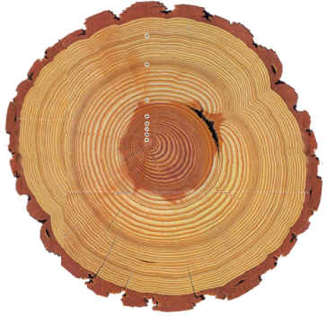

Examine the image of a cross section of a tree.

Use the information from the “anatomy of a tree” to label the following layers. For each layer, provide a brief description of its functions

1. outer bark

2. inner bark

3. cambium.

4. sap wood

5. heart wood.

6. phloem

7. xylem

